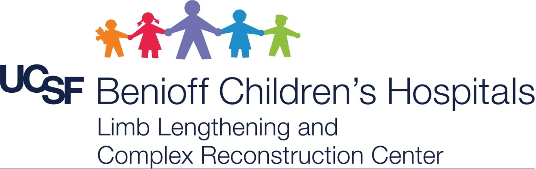

5th Annual UCSF/IGOT Pediatric Limb Differences Webinar
Osteomyelitis in Children and Young Adults:
A Global Perspective

Date: Saturday, June 13, 2026
Time: 6 am- 11.30 am PST
- Target audience- Orthopedic surgeons and learners across the globe
- 4 sessions- 75 mins each with 5-minute breaks after each session
- Each session- Intro talks and Case Presentations (including Take Home points for each presentation)
- Each Intro talk for 7 mins
- Each case presentation for 4 mins
- Panel discussion at the end of each of the 4 sessions
- Expert faculty from around the globe
- NO Registration fee (although registration required to attend)

Preliminary AGENDA

Welcome & Poll Questions (Sabharwal 15 mins)

Session 1: Acute and Subacute Pyogenic Osteomyelitis
Intro Talks: 7 mins each (1 minute transition)
- Reggie Hamdy (Acute and Subacute OM)
- Bamidele Kammen (Osteomyelitis in Children and Adolescents: A Radiologist’s Perspective)
- Prachi Singh (Osteomyelitis in Children and Adolescents: An Infectious Disease Specialist’s Perspective)
Case Presentations: 4 mins each (1 minute transition)
- Spiegel: 14-Year-old with ankle pain
- Maré: 7-year-old with knee pain
- Wijayasinghe: 2-year-old with thigh pain
- Flanagan: 10-year-old with ankle pain
- Schwend: Hip Infection- A Missed Opportunity
- Eidelman: Acute Osteomyelitis of the Femur during Intramedullary lengthening
- Belthur: Progressive Ankle Subluxation Following Resection for Pan-Fibular Osteomyelitis
- Hosny: Acute Pediatric MSK infections Conservative approach

Panel Discussion to follow…
BREAK (5 mins)

Session 2: Chronic Osteomyelitis
Intro Talks: 7 mins each (1 minute transition)
- Pieter Maré (Management of Chronic Osteomyelitis in children)
- David Lowenberg (Chronic Osteomyelitis: An Adult Trauma Surgeon’s Perspective)
- Michael Terry (Chronic Osteomyelitis: A Plastic Surgeon’s Perspective)
Case Presentations: 4 mins each (1 minute transition)
- Banskota: Post-operative osteomyelitis after Femur Fracture
- Belthur: Post-infective Pathologic Femur Shaft Fracture
- Venkat Das: 10-year-old with thigh pain
- Nassaazi: Management of Chronic Osteomyelitis
- Flanagan: 12-year-old with ankle pain
- Morshed: Managing Infected Non-unions in children
- Hosny: Infected open fractures- What to do if the plastic surgeon said I got nothing to do in this case
Panel Discussion to follow…
BREAK (5 mins)

Session 3: Management of Sequelae following osteomyelitis
Intro Talks: 7 mins each (1 minute transition)
- Sandeep Patwardhan (Gap non-unions following Chronic Osteomyelitis)
Case Presentations: 4 mins each (1 minute transition)
- Hosny: Infected nonunion in a child
- Eidelman: Post sepsis “disappearing” Lateral femoral condyle
- McClure: Metaphyseal Osteomyelitis Bone Defect
- McClure: Diaphyseal Bone Defect and Growth Arrest
- Nunn: Modified Huntington’s procedure for shortening and deformity
- Hosny: Infected bone & soft tissue gap

Session 4: Non-pyogenic Osteomyelitis and others...
Intro Talks: 7 mins each (1 minute transition)
- Hitesh Shah (non-pyogenic infections)
- S. Venkat Das (Tips & Tricks)
Case Presentations: 4 mins each (1 minute transition)
- Patwardhan: TB osteomyelitis
- Eidelman: Chronic Sclerosing OM of Garrè
- Spiegel: 17-year-old male with Thigh Pain
- Spiegel: 10-Year-Old Female with persistent Ankle Pain after twisting injury
- Wijayasinghe:15-year-old with arm pain
- Spiegel: 30-month-old with COVID, MRSA Sepsis and left Shoulder Pain
- Shahab: 6 -year-old with arm pain
- Izuagba: 13-year-old with forearm discomfort
- Belthur: One Bone Forearm for Post infective Pseudarthrosis of the Ulna

Panel Discussion to follow…

Closing Remarks: Sanjeev Sabharwal (15 mins)

Registration Link:
