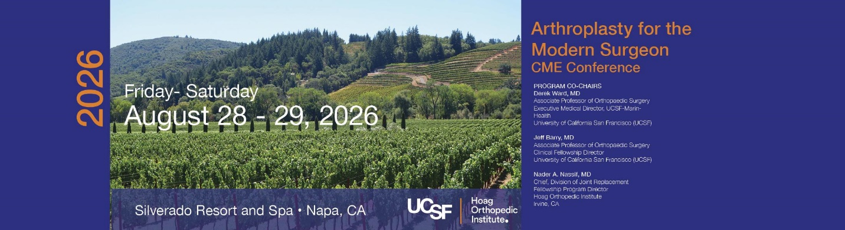
Hoag Orthopedic Institute and the University of California San Francisco School of Medicine Department of Orthopaedic Surgery Jointly Present:
Arthroplasty for the Modern Surgeon
Friday, August 28 - Saturday, August 29, 2026
Silverado Resort and Spa
1600 Atlas Peak Road
Napa, CA 94558
CONFERENCE OVERVIEW:
Our nationally and internationally known faculty have created a dynamic program focused on the latest advances in digital health, and innovative technologies in hip and knee surgery. This primarily case-based program will focus on the general orthopaedic surgeons as well as those who specialize in hip and knee replacement. Combining didactic, case based, and small group breakout sessions, our esteemed faculty hopes to engage the attendee in two days of interactive education.
TARGET AUDIENCE:
The target audience is the surgeon in general orthopaedic practice or arthroplasty surgeon, as well as those interested in the application of modern health technology solutions in orthopaedic practice.
CONFERENCE OBJECTIVES:
An attendee completing this conference will be able to:
• Refine care based on current literature in diagnosis and treatment recommendations.
• Use knowledge of common complications of surgery to improve the quality of practice.
• The attendee will use knowledge of surgical technique to expand the options and improve the
execution of surgical technique in practice.
HIGHLIGHTS:
CME
6 Hands-on Workshops
Wine Reception
Buffet Lunch(s)
World famous Napa attractions!

Accreditation
In support of improving patient care, the University of California, San Francisco is jointly accredited by the Accreditation Council for Continuing Medical Education (ACCME), the Accreditation Council for Pharmacy Education (ACPE), and the American Nurses Credentialing Center (ANCC), to provide continuing education for the healthcare team.
ACCME: UCSF has approved this program for CME credit: UCSF designates this live activity for a maximum of xx.xx AMA PRA Category 1 Credits™. Actual number of credits are currently being reviewed. Physicians should claim only the credit commensurate with the extent of their participation in the activity.



Friday: Knee Day
7:30 Breakfast and Exhibits

8:00 Welcome Introduction

8:05 Journal Club Guided Primary Knee Cases

8:35 Primary Knee Debates and Discussion
- Medial UKA - PF joint matters vs Ignore the patella
  - Patellofemoral complication management
- Medial Stabilized/Crnhy7u8 knee – Keep the PCL vs Throw it Out
  - Medial Stabilized tips/tricks/evidence
- Cementless TKA - Cement is for Sidewalks vs Cement remains the Gold Standard
  - Considerations in cementless TKAs

9:45 Break - Visit Exhibits and Coffee Refill

10:00 Keynote Lecture: Visiting Professor - Dr Antonia Chen
1030: Rotating Breakouts (NON-CME)
See badge for group number – x3 30min sessions
12:00 Working Lunch - Tech and Business in Arthroplasty
- CJRX
- Health Policy Update
- AI in Ortho
- OR Tech Talk

1:00 Complex and Revision TKA Cases and Hop Topics
- Fully Cemented Stem
- Distal Femoral Replacement - Crash Course
- Recurrent Swelling, NonInfectious

2:15 Break - Visit Exhibitsu7

2:30 Intraop Nightmare Panel - Complications and How to Manage

4:00 Adjourn/Welcome Reception

Saturday: Hip Day
7:30 Breakfast and Exhibits

8:00 Welcome Introduction

8:05 Hip Hot Topic Debates
- Hip Cup Placement (8min total debate)- Fluoro/Nav/Robot vs Manual
  - Radiation Safety Refresher
- DA Incision - Bikini vs Vertical
  - Bikini DA - Tips/Tricks
- B2 Periprosthetic Fracture in Elderly - ORIF vs Revision
  - Periprosthetic Fracture Fixation - What’s New

9:15 Keynote Lecture: Visiting Professor - Dr Antonia Chen

9:45 Break - Visit Exhibits and Coffee Refill

10:00 Updates in Total Joint Arthroplasty
- Postop Care in 2026 - Evidence vs Dogma
- GLP-1 update
- Novel Pain Management Options
10:45 Rotating Breakouts (NON-CME)
See badge for group number – x3 30min sessions
12:15 Lunch (On the Lawn)

1:00 Complications and Revision THA Topics
- Anterior Revision - Who, What…and Why?
- Conversion THA - 5 Tips/Tricks
- Resurgence of the monoblock revision stem

1:30 Break - Final Industry Exhibit Time

1:40 Intraop Nightmare Panel - Complications and How to Manage

2:30 Inaugural Disasterplasty World Cup 2026….

4:00 Adjourn/Evaluations/CME Credits

PROGRAM CO-CHAIRS
Derek Ward, MD
Associate Professor of Orthopaedic Surgery
Executive Medical Director, UCSF-MarinHealth
University of California San Francisco (UCSF)

Jeff Barry, MD
Associate Professor of Orthopaedic Surgery
Clinical Fellowship Director
University of California San Francisco (UCSF)

Nader A. Nassif, MD
Chief, Division of Joint Replacement
Fellowship Program Director
Hoag Orthopedic Institute
Irvine, CA
KEYNOTE SPEAKER
Antonia F. Chen, MD, MBA
Professor
Chair, Department of Orthopaedic Surgery
UT Southwestern Medical Center
COURSE FACULTY (University of California, San Francisco)
Thomas Barber, MD
Professor
Arthritis & Joint Replacement
University of California San Francisco (UCSF)

Stefano A. Bini, MD
Maria Manetti Shrem Endowed Professor of Orthopaedic Surgery
Chief Technology Officer
University of California San Francisco (UCSF)
Erik N. Hansen, MD
William Murray Endowed Chief of Arthroplasty
Professor of Orthopaedic Surgery
University of California San Francisco (UCSF)

Alfred Kuo, MD
Vice Chair San Francisco Veterans Affairs
Professor of Orthopaedic Surgery
University of California San Francisco (USCF)

Claudio Diaz Ledezma, MD
Associate Professor of Orthopaedic Surgery
University of California San Francisco (USCF)

Lyndly Tamura, MD
Assistant Professor
Health Sciences Assistant Clinical Professor
Physical Medicine and Rehabilitation
University of California San Francisco (USCF)

Kudret Usmani, MD
Assistant Professor
Arthritis & Joint Replacement
University of California San Francisco (USCF)

Anthony Wiggins, MD
Assistant Professor of Orthopaedic Surgery
University of California San Francisco (UCSF)
COURSE FACULTY (Hoag Orthopedic Institute)
Travis Scudday, MD
Hoag Orthopedic Institute
Irvine, CA
Steven Barnett, MD
Hoag Orthopedic Institute
Irvine, CA
Michael Hunter, MD
Hoag Orthopedic Institute
Irvine, CA
Joseph Koressel MD
Hoag Orthopedic Institute
Irvine, CA
DISTIGUISHED GUEST FACULTY
Nima Eftekhary, MD
Orthopedics
Kaiser Permanente
Walnut Creek Medical Center
Antioch Medical Center
Keith Fehring, MD
Orthopaedic Surgeon
OrthoCarolina
Charlotte, NC

Craig Hogan, MD, FAAOS, FAOA
Associate Professor
Chief, Adult Reconstructive Surgery
Adult Reconstruction Fellowship Director
Inpatient Medical Director, Orthopaedic Surgery
Practice Director, Orthopaedic Outpatient Services
University of Colorado Hospital
Department of Orthopaedic Surgery
Aurora, CO
Eli Kamara, MD, FAAOS
Assistant Professor of Orthopaedic Surgery
Albert Einstein College of Medicine
Montefiore Medical Center
Bronx, NY

