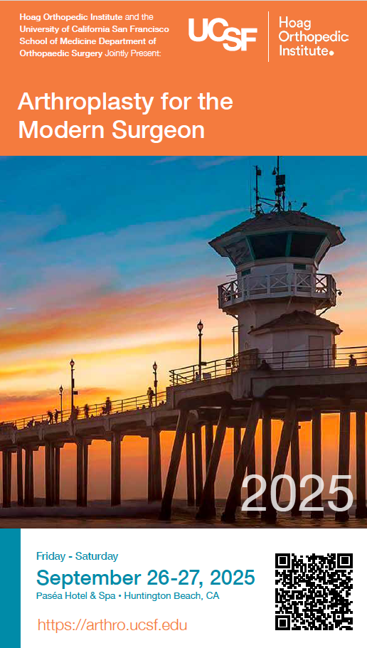
PROGRAM CO-CHAIRS
Derek Ward, MD
Associate Professor of Orthopaedic Surgery
Executive Medical Director, UCSF-MarinHealth
University of California San Francisco (UCSF)

Jeff Barry, MD
Associate Professor of Orthopaedic Surgery
Clinical Fellowship Director
University of California San Francisco (UCSF)

Nader A. Nassif, MD
Chief, Division of Joint Replacement
Fellowship Program Director
Hoag Orthopedic Institute
Irvine, CA

2025 KEYNOTE SPEAKER
Nicholas Bernthal, MD
Chair, Department of Orthopedic Surgery
David Geffen School of Medicine, University of California, Los Angeles (UCLA)

COURSE FACULTY (Hoag Orthopedic Institute)
Steven Barnett, MD
Chief Medical Officer
Hoag Orthopedic Institute
Irvine, CA

Robert Gorab, MD
Tom & Mayumi Adams Endowed Chair in Orthopedic Surgery
Hoag Orthopedic Institute
Irving, CA

Andrew Guarni
Executive Vice President, Chief Financial Officer
Hoag Hospital
Newport Beach, CA

Klane Hales, MD
Hoag Orthopedic Institute
Irvine, CA

Michael Hunter, MD
Hoag Orthopedic Institute
Irvine, CA

Travis Scudday, MD
Hoag Orthopedic Institute
Irvine, CA

Matthew Siljander, MD
Hoag Orthopedic Institute
Irvine, CA

David So, MD
Hoag Orthopedic Institute
Irvine, CA

COURSE FACULTY (University of California, San Francisco)
Stefano A. Bini, MD
Maria Manetti Shrem Endowed Professor of Orthopaedic Surgery
Chief Technology Officer
University of California San Francisco (UCSF)

Erik N. Hansen, MD
William Murray Endowed Chief of Arthroplasty
Professor of Orthopaedic Surgery
University of California San Francisco (UCSF)

Alfred Kuo, MD
Vice Chair San Francisco Veterans Affairs
Professor of Orthopaedic Surgery
University of California San Francisco (USCF)

Claudio Diaz Ledezma, MD
Associate Professor of Orthopaedic Surgery
University of California San Francisco (USCF)

Anthony Wiggins, MD
Assistant Professor of Orthopaedic Surgery
University of California San Francisco (UCSF)

DISTIGUISHED GUEST FACULTY
Nathanael Heckmann, MD, FAAOS
Assistant Professor of Orthopaedic Surgery
University of Southern California Keck School of Medicine

Eli Kamara, MD, FAAOS
Assistant Professor of Orthopaedic Surgery
Albert Einstein College of Medicine
Montefiore Medical Center
Bronx, NY

Howard J. Marans, MD, MSc, FRCSC
Executive Director, Medical Health Services
Aetna

Adam A. Sassoon, MD, MS
UCLA Santa Monica Medical Center
Santa Monica, CA

General Information

Evaluation
Your opinion is important to us – we do listen! Please complete the course evaluation online as it is important to future course planning.

https://arthro.ucsf.edu/
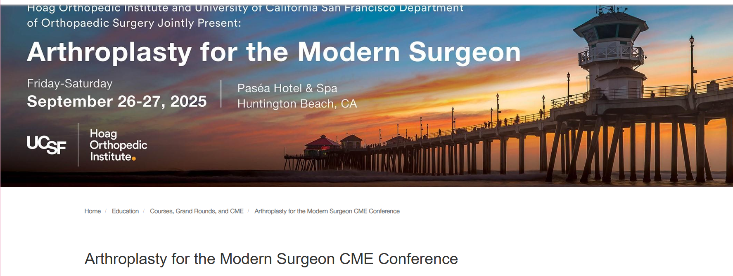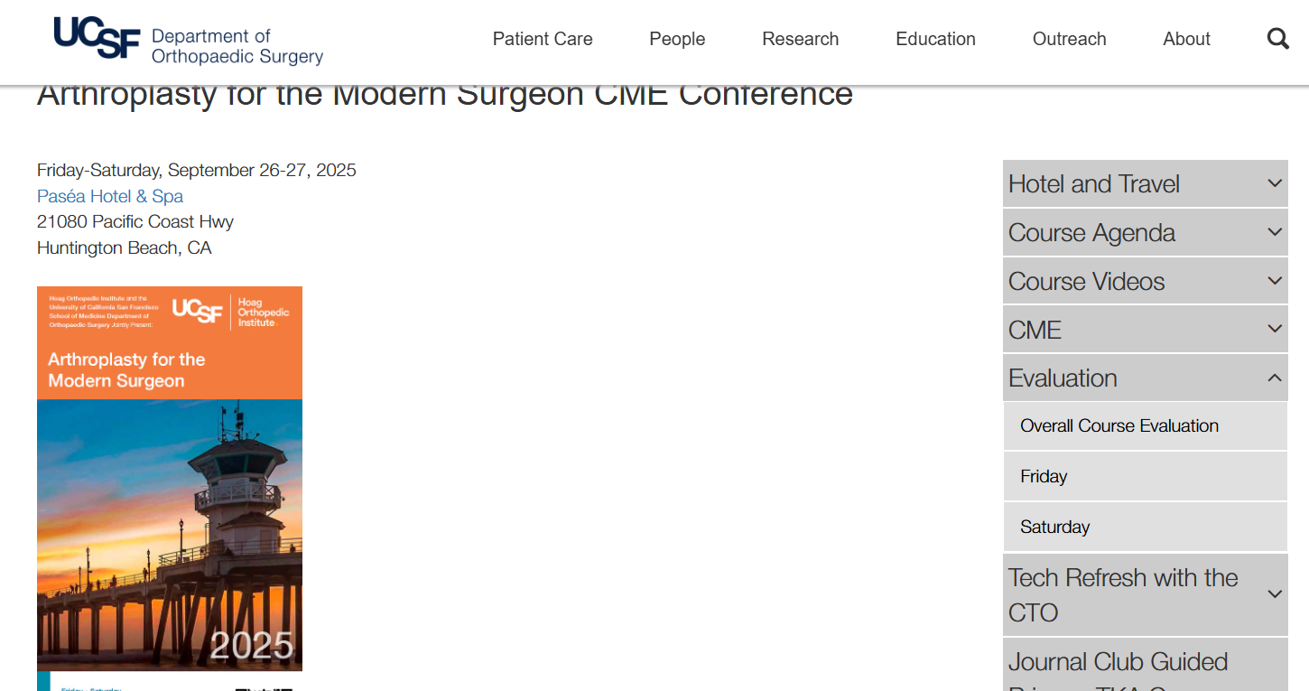

Security
We urge caution with regard to your personal belongings and syllabus books. We are unable to replace these in the event of loss. Please do not leave any personal belongings unattended in the meeting room during lunch or breaks.
Social Activities
Welcome Reception
Friday, 4-6pm
Guests invited

Accreditation
In support of improving patient care, the University of California, San Francisco is jointly accredited by the Accreditation Council for Continuing Medical Education (ACCME), the Accreditation Council for Pharmacy Education (ACPE), and the American Nurses Credentialing Center (ANCC), to provide continuing education for the healthcare team.
ACCME: UCSF has approved this program for CME credit: UCSF designates this live activity for a maximum of 13.00 AMA PRA Category 1 Credits™. Physicians should claim only the credit commensurate with the extent of their participation in the activity.



To Claim your CME certificate
The UCSF CME Office has transferred to a new online system.
Your account has been transferred for you however we request you log in and verify:
https://ucsf.cloud-cme.com
To claim credit:
Step 1
Go the new CE Portal https://ucsf.cloud-cme.com
Sign in
Navigate to MY CME
Select Claim Credit
Enter the activity code (14076)
Attest to the number of hours (13 total)
and then you can receive their certificates once the conference ends Saturday.
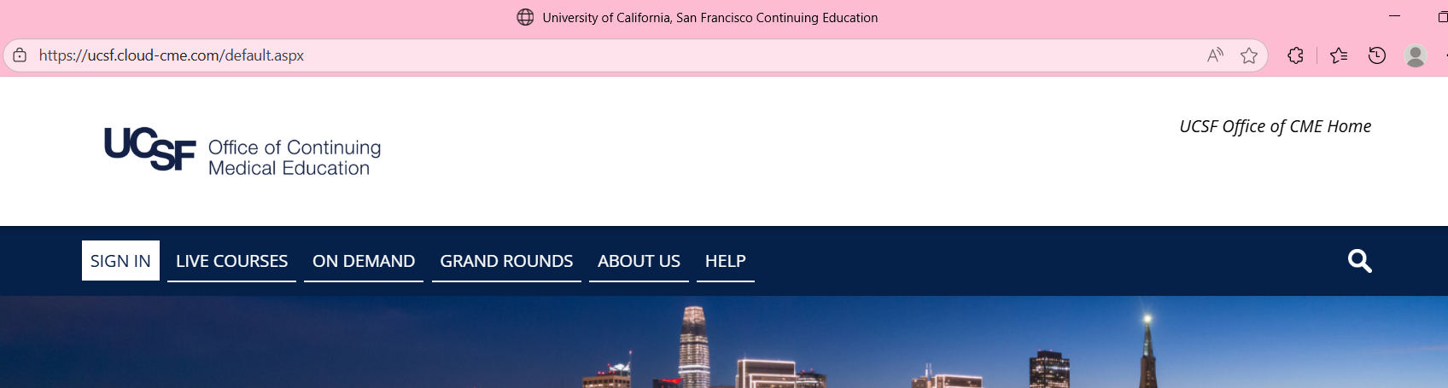

Acknowledgement of Commercial Support:
Educational Grants and In-kind Donations
Thank You to Our Supporters
HANDS-ON WORKSHOP
Johnson & Johnson Med Tech
Smith Nephew
ZimmerBiomet

EXHIBITORS
Acera
Biocomposites
Code Technology
Corin Group
Heron Therapeutics
J&J Medtech
Kinamed
Onkos
Orthoalign
Ostetic
Pacira
Smith & Nephew
Stryker
Sylke
Veritex
ZimmerBiomet

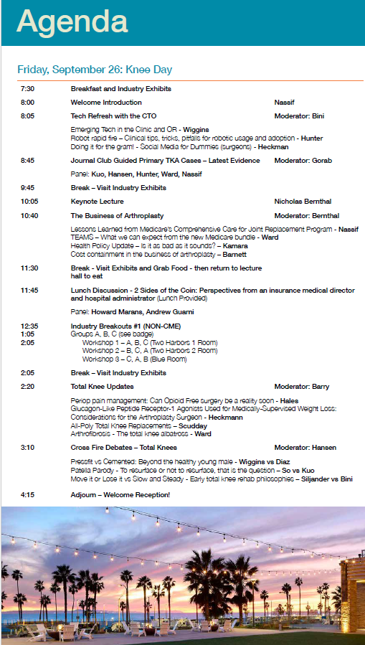

Hands-on Workshops with Rotating Sessions: FRIDAY
Workshop 1 – SmithNephew (Two Harbors 1 Room)
12:35-1:00pm Group A
1:05-1:30pm Group B
1:35-2:05pm Group C
Workshop 2 – ZimmerBiomet (Two Harbors 2 Room)
12:35-1:00pm Group B
1:05-1:30pm Group C
1:35-2:05pm Group A
Workshop 3 – J&J Medtech (Blue Room)
12:35-1:00pm Group C
1:05-1:30pm Group A
1:35-2:05pm Group B

Hands-on Workshops with Rotating Sessions: SATURDAY
Workshop 1 – SmithNephew (Two Harbors 1 Room)
10:00-10:25am Group A
10:30-10:55am Group B
11:00am-11:25am Group C
Workshop 2 – ZimmerBiomet (Two Harbors 2 Room)
10:00-10:25am Group B
10:30-10:55am Group C
11:00am-11:25am Group A
Workshop 3 – J&J Medtech (Blue Room)
10:00-10:25am Group C
10:30-10:55am Group A
11:00am-11:25am Group B

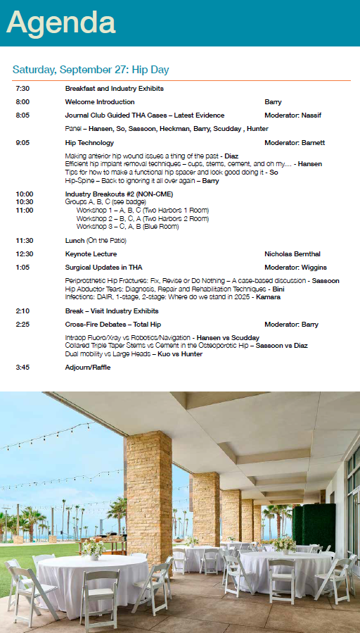

Federal and State Law
Regarding Linguistic Access and Services for Limited English Proficient Persons

- Purpose.
This document is intended to satisfy the requirements set forth in California Business and Professions code 2190.1. California law requires physicians to obtain training in cultural and linguistic competency as part of their continuing medical education programs. This document and the attachments are intended to provide physicians with an overview of federal and state laws regarding linguistic access and services for limited English proficient (“LEP”) persons. Other federal and state laws not reviewed below also may govern the manner in which physicians and healthcare providers render services for disabled, hearing impaired or other protected categories

- Federal Law – Federal Civil Rights Act of 1964, Executive Order 13166, August 11, 2000, and Department of Health and Human Services (“HHS”) Regulations and LEP Guidance.
The Federal Civil Rights Act of 1964, as amended, and HHS regulations require recipients of federal financial assistance (“Recipients”) to take reasonable steps to ensure that LEP persons have meaningful access to federally funded programs and services. Failure to provide LEP individuals with access to federally funded programs and services may constitute national origin discrimination, which may be remedied by federal agency enforcement action. Recipients may include physicians, hospitals, universities and academic medical centers who receive grants, training, equipment, surplus property and other assistance from the federal government.

HHS recently issued revised guidance documents for Recipients to ensure that they understand their obligations to provide language assistance services to LEP persons. A copy of HHS’s summary document entitled “Guidance for Federal Financial Assistance Recipients Regarding Title VI and the Prohibition Against National Origin Discrimination Affecting Limited English Proficient Persons – Summary” is available at HHS’s website at: http://www.hhs.gov/ocr/lep/ .

As noted above, Recipients generally must provide meaningful access to their programs and services for LEP persons. The rule, however, is a flexible one and HHS recognizes that “reasonable steps” may differ depending on the Recipient’s size and scope of services. HHS advised that Recipients, in designing an LEP program, should conduct an individualized assessment balancing four factors, including: (i) the number or proportion of LEP persons eligible to be served or likely to be encountered by the Recipient; (ii) the frequency with which LEP individuals come into contact with the Recipient’s program; (iii) the nature and importance of the program, activity or service provided by the Recipient to its beneficiaries; and (iv) the resources available to the Recipient and the costs of interpreting and translation services.

Based on the Recipient’s analysis, the Recipient should then design an LEP plan based on five recommended steps, including: (i) identifying LEP individuals who may need assistance; (ii) identifying language assistance measures; (iii) training staff; (iv) providing notice to LEP persons; and (v) monitoring and updating the LEP plan.

A Recipient’s LEP plan likely will include translating vital documents and providing either on-site interpreters or telephone interpreter services, or using shared interpreting services with other Recipients. Recipients may take other reasonable steps depending
on the emergent or non-emergent needs of the LEP individual, such as hiring bilingual
staff who are competent in the skills required for medical translation, hiring staff interpreters, or contracting with outside public or private agencies that provide interpreter services. HHS’s guidance provides detailed examples of the mix of services that a Recipient should consider and implement. HHS’s guidance also establishes a “safe harbor” that Recipients may elect to follow when determining whether vital documents must be translated into other languages. Compliance with the safe harbor will be strong evidence that the Recipient has satisfied its written translation obligations.

In addition to reviewing HHS guidance documents, Recipients may contact HHS’s Office for Civil Rights for technical assistance in establishing a reasonable LEP plan.

- California Law – Dymally-Alatorre Bilingual Services Act.
The California legislature enacted the California’s Dymally-Alatorre Bilingual Services Act (Govt. Code 7290 et seq.) in order to ensure that California residents would appropriately receive services from public agencies regardless of the person’s English language skills. California Government Code section 7291 recites this legislative intent as follows:

“The Legislature hereby finds and declares that the effective
maintenance and development of a free and democratic society depends
on the right and ability of its citizens and residents to communicate
with their government and the right and ability of the government to
communicate with them.

The Legislature further finds and declares that substantial
numbers of persons who live, work and pay taxes in this state are
unable, either because they do not speak or write English at all, or
because their primary language is other than English, effectively to
communicate with their government. The Legislature further finds and
declares that state and local agency employees frequently are unable
to communicate with persons requiring their services because of this
language barrier. As a consequence, substantial numbers of persons
presently are being denied rights and benefits to which they would
otherwise be entitled.

It is the intention of the Legislature in enacting this chapter to
provide for effective communication between all levels of government
in this state and the people of this state who are precluded from
utilizing public services because of language barriers.”

The Act generally requires state and local public agencies to provide interpreter and written document translation services in a manner that will ensure that LEP individuals have access to important government services. Agencies may employ bilingual staff, and translate documents into additional languages representing the clientele served by the agency. Public agencies also must conduct a needs assessment survey every two years documenting the items listed in Government Code section 7299.4, and develop an implementation plan every year that documents compliance with the Act. You may access a copy of this law at the following url: http://www.spb.ca.gov/bilingual/dymallyact.htm

Disclosures

The following faculty speakers, moderators and planning committee members have disclosed NO financial interest/arrangement or affiliation with any commercial companies who have provided products or services relating to their presentation(s) or commercial support for this continuing medical education activity:
Andrew Guarni
Klane Hales, MD
Michael Hunter, MD
Claudio Diaz Ledezma, MD
Anthony Wiggins, MD
Eli Kamara, MD, FAAOS
Alfred Kuo, MD, PhD
Howard J. Marans, MD, MSc, FRCSC
The following faculty speakers have disclosed a financial interest/arrangement or affiliation with a commercial company who has provided products or services relating to their presentation(s) or commercial support for this continuing medical education activity. All conflicts of interest have been resolved in accordance with the ACCME Updated Standards for Commercial Support:

Derek Ward, MD
Johnson & Johnson, Consultant, Royalties
Visie, Stock
Jeff Barry, MD
Smith&Nephew Consultant
Onkos Surgical Consultant
J&J MedTech Consultant

Nader A. Nassif, MD
Depuy Synthes Consultant, Speaks Honorarium, Royalties

Matthew Siljander, MD
Enovis, Consultant
Adam A. Sassoon, MD, MS
Biocomposites, Consultant
Smith&Nephew, Consultant
ZimmerBiomet, Consultant

Nicholas Bernthal, MD
Daiichi Sankyo, Consultant
Merck, Consultant
ZimmerBiomet, Research Support
David So, MD
Microport Orthopaedics, Consultant
United Orthopaedics, Consultant
Nathanael Heckmann, MD, FAAOS
ZimmerBiomet, Development
Envois, Development

Travis Scudday, MD
Syke, Owner
HOI, Owner
Exactech, Consultant
Corin, Consultant

Erik N. Hansen, MD
Corin, Consultant
SmithNephew, Consultant
Steven Barnett, MD
DePuy, Royalties, Consultant, Research Support
Sylke, Royalties, Consultant, Research Support
ZimmerBiomet, Research Support
Robert Gorab, MD
DePuy, Royalties, Consultant, Holder of IP
Stefano A. Bini, MD
ZimmerBiomet, Consultant
Archetypeai; Gate Science; SiraMedical.com; InSilicoTrials, StartUp Health, CaptureProof, Stock/Stock Options
This UCSF CME educational activity was planned and developed to:
Uphold academic standards to ensure balance, independence, objectivity, and scientific rigor; Adhere to requirements to protect health information under the Health Insurance Portability and Accountability Act of 1996 (HIPAA); and, include a mechanism to inform learners when unapproved or unlabeled uses of therapeutic products or agents are discussed or referenced.

This activity has been reviewed and approved by members of the UCSF CME Governing Board in accordance with UCSF CME accreditation policies. Office of CME staff, planners, reviewers, and all others in control of content have no relevant financial relationships to disclose.



