San Francisco Bay Area & Beyond

San Francisco, the ‘central hub’ of the Bay Area and even Northern California, has been home to diverse communities who collaborate to create a broad spectrum of entertainment, art and food, amongst other things. Great activities riddle Northern California, which boasts regions like Napa Valley, Lake Tahoe, Monterey Bay, and the San Francisco Bay Area.
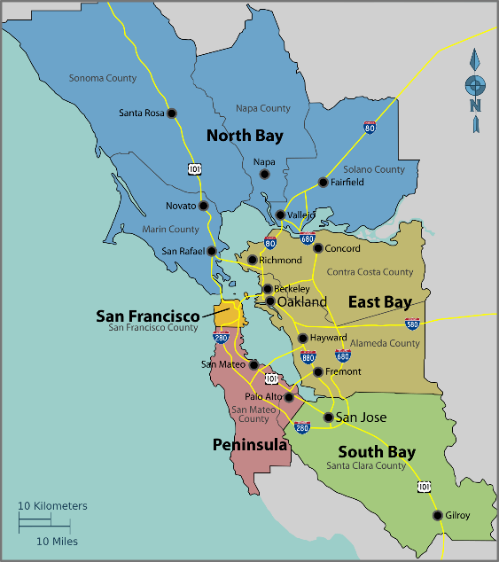
The Bay Area itself is best visualized with San Francisco being the center/western edge. East Bay includes cities like Oakland, Berkeley and Fremont; South Bay/Peninsula includes Palo Alto, Mountain View and San Jose; and North Bay includes Marin, Sausalito and Petaluma. Food in the area emulates the close proximity to a strong agricultural presence in the Central Valley and diverse ethnic backgrounds.
Ranging from Michelin star restaurants to food trucks, with gastronomical ingenuities on display from cultures all over the world, the Bay Area offers the culinary tastes and adventures for everyone.
Accompanying the cuisine are wineries, old and newer, with higher concentrations in the famous Napa Valley area just north of SF. A rising brewing scene continues to expand on their ingredients, flavors and the brewing spaces. The large Asian and Latino populations offer some of the more ‘authentic’ and

delicious options in the area. There are endless great options and cultures with styles for everyone.
Figure 1: Bay Area Map

Many bridges help keep Bay Areans connected, with the most iconic being the Golden Gate Bridge, which connects San Francisco to the North Bay. The Bay Bridge, which is older than the Golden Gate by 6 months, links Oakland and San Francisco together. While compatible for cars and bikes, BART (Bay Area Rapid Transit), SF Muni, Caltrain offer affordable and convenient public subways & trains, as well as many bus services, which help make maneuvering the Bay Area more efficient.
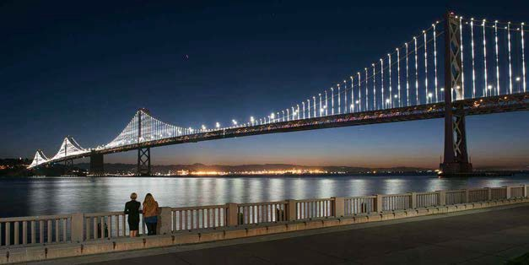
Public transit can be especially useful for attending large events such as professional sports games and concerts. The current most popular sports team are the Golden State Warriors, who currently reside in Oakland at Oracle Arena, but will be moving to the Chase Center that is under construction across the street from our own facilities at the UCSF Mission Bay campus before the 2019-
Figure 2: SF-Oakland Bay Bridge 2020 season.

Also nearby is AT&T Park, the home of the San Francisco Giants, one of our local baseball teams, which boasts beautiful views of the water. Other Nor-Cal professional teams include; Oakland Athletics (MLB), Oakland Raiders (NFL- Moving to Las Vegas), San Francisco 49ers (NFL moved to Santa Clara), San Jose Earthquakes (MLS), San Jose Sharks (NHL) and the Sacramento Kings (NBA).
Great music/entertainment venues litter the area. From the aforementioned sports

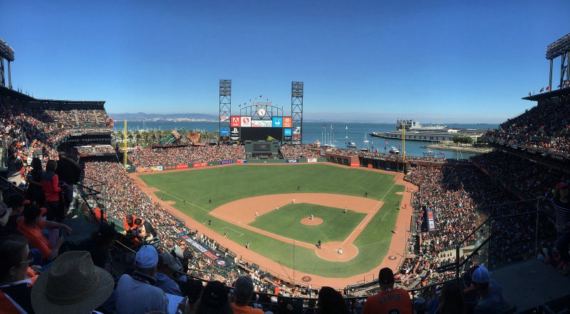
Figure 3: AT&T Park

arenas to more ‘historic’ ones such as the Greek Theater on Cal Berkeley’s campus to a litany of smaller venues in just about all the major cities around. Finding ample entertainment opportunities can sometimes be a search, but the diversity and number of activities should make it easier for those with the most obscure tastes.
There are many varieties of outdoor activities within the city and within driving distance. In SF you can take in views at Twin Peaks, have a bonfire/BBQ at Ocean Beach, attend events at Golden Gate Park or Picnic in the Presidio, kayak/boat in the bay, to name a few. A few popular places of interest in Nor- Cal include Muir Woods, Yosemite, Lake Tahoe, & Monterey Bay. In addition, being centrally located on the US west coast comes in handy should one ever wish to explore the coast and area. Whether it
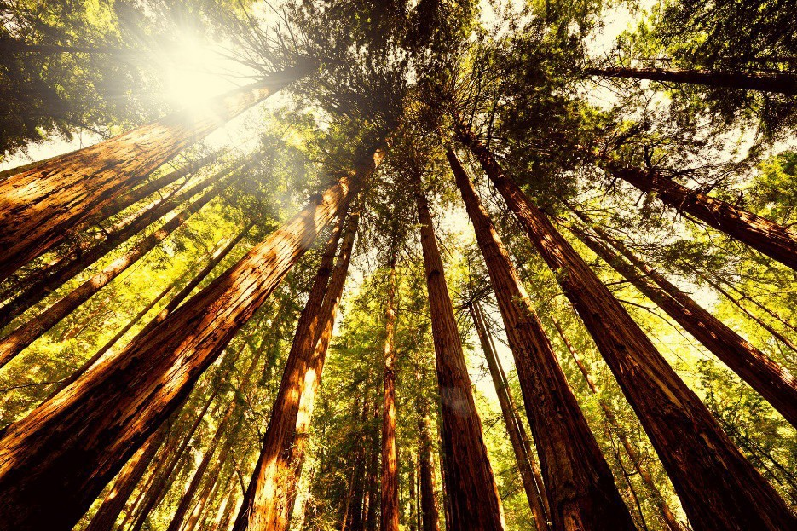
be a scenic drive on Highway 1, or a short plane ride to cities like Los Angeles, Las Vegas, Seattle & Portland to name a few; San Francisco sits well in the middle.
We hope you can take some time to appreciate the beauty of San Francisco and the Bay Area, especially while in the warmer less foggy months! If you are looking to find a certain activity, food spot, or just general suggestions, please feel free to reach out to your residents, faculty or come by our office and chat with anyone on our education staff!
Figure 4: Muir Woods

